Assignment

Stage One Submission

2805ICT/3815ICT/7805ICT

Group Number: Group 5

Student name Xinghan Tai Student ID s5251658 Enrolled Course Code: 3815ICT

Student name Quang Huy Nguyen Student ID s5257464 Enrolled Course Code: 7805ICT

Student name Yen-Cheng, Chen Student ID s5216615 Enrolled Course Code: 3815ICT

# Table of Contents

Table of Contents 2

1.0 Project Planning and Documentation 3

1.1 Time Schedule 3

1.2 Total working hours 3

1.3 Effort and contribution table 3

1.4 Version Control System 4

2.0 Requirements Analysis 4

2.1 Functional requirements 4

2.2 Non-functional requirements 4

2.3 Use case diagram 4

2.4 Full use case description 4

2.5 Requirement - use case traceability matrix 4

2.6 Activity diagram 4

3.0 Video link 5

# 1.0 Project Planning and Documentation

## 1.1 Time Schedule

This table should reflect who did what, how long you expected sections to take and the actual hours it took to perform the tasks.

|  |  |  |  |  |  |  |  |  |
| --- | --- | --- | --- | --- | --- | --- | --- | --- |
| **Task** | | **Plan** | | | | **Actual** | | |
| # | Task Name | Student | Planed Time | Cumulative  Time | Finished Date | Time | Cumulative Time | Finished Date |
| 1 | Project plan | All | 2 | 6 | 05/08/22 | 2 | 6 | 05/08/22 |
| 2 | Identify Functional Requirement | Xinghan Tai and Quan Huy Nguyen | 3 | 6 | 12/08/22 | 3 | 6 | 12/08/22 |
| 3 | Identify use case | Yen-cheng Chen and Quan Huy Nguyen | 3 | 6 | 12/08/22 | 3 | 6 | 12/08/22 |
| 4 | Coding | All | 10 | 30 | 23/08/22 | 13 | 39 | 23/08/22 |
| 5 | Documentation | All | 2 | 6 | 26/08/22 | 1.5 | 4.5 | 26/08/22 |

## 1.2 Total working hours

|  |  |  |
| --- | --- | --- |
| **Student Name (#ID)** | **Plan (hours)** | **Actual (hours)** |
| **Xinghan Tai s5251658** | 14 | 15 |
| **Quang Huy Nguyen s5257464** | 18 | 20 |
| **Yen-cheng Chen s5257464** | 15 | 15 |
|  |  |  |
| **Total working hours** | 37 | 40 |
| **Average working hours per person** | 12.33 | 13.33 |

## 1.3 Effort and contribution table

|  |  |  |  |
| --- | --- | --- | --- |
| **Student** | **Effort Level\***  (Rating from 0 – 5, the information is filled by the group) | **Contribution Level\***  (Rating from 0 – 5, the information is filled by the group) | **Justification**  If a student received level rating of 3 or less, your group need to give explanation for the low level rating |
| **Quang Huy Nguyen** | 5 | 5 |  |
| **Yen-cheng Chen** | 5 | 4 |  |
| **Xinghan Tai** | 5 | 4 |  |
|  |  |  |  |
| **Total** | 15 | 13 |  |

* *Level ratings, 5 = excellent, 4 = good, 3 = reasonable, 2 = poor, 1 = unacceptable, 0 = none

## 1.4 Version Control System

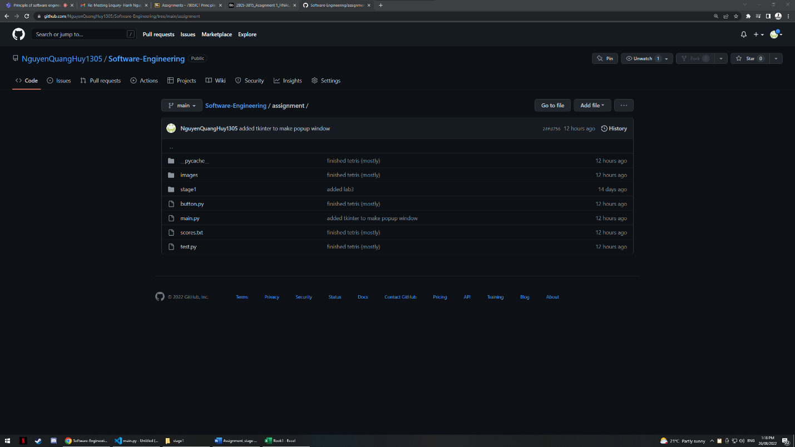

# 2.0 Requirements Analysis

## 2.1 Functional requirements

|  |  |  |
| --- | --- | --- |
| Identifier | Priority | Requirements |
| F-REQ 1 | 1 | The system is planned to run on at least two platforms. |
| F-REQ 2 | 1 | The system will display the start-up page when the game is started. |
| F-REQ 3 | 1 | The start-up page should contain the title of Tetris. |
| F-REQ 4 | 1 | The start-up page should display the current year and the course code. |
| F-REQ 5 | 1 | The start-up page should display a list of students in the group. |
| F-REQ 6 | 2 | The system should contain an exit button to exit the program. |
| F-REQ 7 | 1 | The system should display a score button to show the top 10 players and their high scores. |
| F-REQ 8 | 3 | The configure button shown on the start-up page when pressed will take the player to a configure page where they can select normal game / game with extension, select the different size of the field, the blocks’ dropping speed, and AI game. |
| F-REQ 9 | 2 | The start-up page should contain a play button that takes the player to the game. |
| F-REQ 10 | 1 | The game screen should display an empty field when started, this is the area for the blocks to fall and build. |
| F-REQ 11 | 3 | The blocks should appear and starts falling from the top of the field without any manipulation from the users. |
| F-REQ 12 | 3 | The player should be able to manipulate the blocks’ x axis by pressing the left (decrease in x axis) and right (increase in x axis) arrow keys, the y axis by pressing the down arrow key (only able to decrease the y axis therefore, making the block to fall faster), and rotating the block 90 degrees clockwise by pressing the up-arrow key. |
| F-REQ 13 | 4 | When the blocks touch the ground/another block, the user will lose the ability to manipulate the current block and a new block will start falling from the top of the field, the user will gain the ability to manipulate the new block that were created until it touches the ground/another block then repeat this process. |
| F-REQ 14 | 3 | When the blocks forms a complete line/multiple complete lines the game will return a sound effect and the completed lines of blocks will disappear with scores added to the user's scoring system (1 line = 100 points, 2 lines = 300 points, 3 lines = 600 points and 4 = 1000 points) |
| F-REQ 15 | 2 | When “P” is pressed the game should pause and when pressed again the game should resume |
| F-REQ 16 | 2 | When the “esc” key is pressed the system should display a dialog box asking if the player would like to end the game, If the user selects “Yes” then return to the starting page, if they select “No” then continue the game. |
| F-REQ 17 | 3 | When “M” is pressed it will mute/unmute the music and sound effects based on their current status. |

## 2.2 Non-functional requirements

|  |  |  |
| --- | --- | --- |
| Identifier | Priority | Requirement |
| NF-REQ 1 | 2 | usability-The system will have a “Instructions” page to demonstrate how the players can interact with the game. |
| NF-REQ 2 | 3 | usability-The system will be aesthetically pleasing. |
| NF-REQ 3 | 4 | The system shouldn’t require much memory or computing speed to run locally. |

## 2.3 Use case diagram

1. Start the game (UC-1)

User can press the start button at the start page to start the game

1. Show the score (UC-2)

User can press the score button to see the top 10 highest score

1. Moving shape (UC-3)

User can press right and left arrow to control the shape goes right and left

1. Turn shape (UC-4)

User can press up arrow to flip the shape in 90 degree

1. Speed up (UC-5)

User can press down arrow speed up failing speed of the shape

1. Eliminate the blocks (UC-6)

When User full a row of the empty blocks by shapes, the blocks will be eliminated and the score will be increased

1. Pause the game (UC-7)

User can press P to pause the game and press P to start it again

1. Give up the game (UC-8)

User can press ESC to quit the game, when user press ESC the page will pop up and ask if user want to quit or not, the user can choose yes to quit or no to continue

1. Turn on/off the sound effect (UC-9)

User can press M to close or open the sound effect

1. AI game (UC-10)

User can go the configuration page by pressing ESC and choose open the AI game selection to make the AI to control the game

1. End the game (UC-11)

When the user fill all the playground and cannot eliminate blocks anymore, the game will end and shows the score

## Full use case description

|  |  |  |
| --- | --- | --- |
| **Use case name** | Eliminate the blocks | |
| **Scenario** | Player can eliminate the blocks to get point | |
| **Triggering event** | Player playing the game | |
| **Brief description** | Player can move the block to fill the x axis in the playground, when the playground is full all the blocks will be eliminated. | |
| **Actor** | Player, System | |
| **Related use case** | Moving shape, Turn shape, Speed up | |
| **Stakeholders** | Player, Developer | |
| **Preconditions** | The x axis is full of blocks  The shape is not out of the playground | |
| **Post conditions** | Player will get 100 point for score  The x axis will clear one line and the block above will fall down one block | |
| **Flow of activities:** | **User** | **System** |
|  | 1 Press start button | * 1. Set up the game environment   2. Show the menu   3. Begin the game   4. Build the playground |
|  | 2 Control the shapes | 2.1 Detect the player’s movement  2.2 Move/ Turn/ Speed up the blocks  2.3 Sets the blocks in the bottom of the playground |
|  | 3 Fill in the x axis | 3.1 Add 100 point to the score board |
| **Exception conditions** | If the user fill the x axis while the block exceed the whole playground, the game will end except getting points | |

## Requirement - use case traceability matrix

|  |  |  |  |  |  |  |  |  |  |  |  |
| --- | --- | --- | --- | --- | --- | --- | --- | --- | --- | --- | --- |
|  | UC-1 | UC-2 | UC-3 | UC-4 | UC-5 | UC-6 | UC-7 | UC-8 | UC-9 | UC-10 | UC-11 |
| F-REQ1 |  |  |  |  |  |  |  |  |  |  |  |
| F-REQ2 | x |  |  |  |  |  |  |  |  | x |  |
| F-REQ3 | x | x |  |  |  |  |  |  |  |  |  |
| F-REQ4 | x |  |  |  |  |  |  |  |  |  |  |
| F-REQ5 | x |  |  |  |  |  |  |  |  |  |  |
| F-REQ6 | x |  |  |  |  |  |  |  |  |  | x |
| F-REQ7 |  | x |  |  |  |  |  |  |  |  |  |
| F-REQ8 |  |  |  |  |  |  |  |  |  | x |  |
| F-REQ9 | x |  |  |  |  |  |  |  |  |  |  |
| F-REQ  10 |  |  | x | x | x |  |  |  |  |  |  |
| F-REQ  11 |  |  | x | x | x |  |  |  |  |  |  |
| F-REQ  12 |  |  | x | x | x |  |  |  |  |  |  |
| F-REQ  13 |  |  |  |  |  | x |  |  |  |  |  |
| F-REQ  14 |  | x |  |  |  |  |  |  |  |  |  |
| F-REQ  15 |  |  |  |  |  |  | x |  |  |  |  |
| F-REQ  16 |  |  |  |  |  |  |  | x |  |  |  |
| F-REQ  17 |  |  |  |  |  |  |  |  | x |  |  |

## 2.6 Activity diagram

# 3.0 Video link

<https://youtu.be/1d_mPI3Mth0>